VISUALIZATION
Visualization is the process of representing data and information in graphical formats such as charts, graphs, and plots to make the data easier to understand. It helps in identifying patterns, trends, and relationships within the data that may not be easily visible in raw numerical form. In data science, visualization plays an important role in data analysis, decision making, and communication of insights. Python provides various visualization libraries such as Matplotlib, Seaborn, Plotly, and Bokeh which help in creating effective and meaningful visual representations of data. Data visualization is widely used in fields like business analytics, scientific research, and machine learning to interpret complex datasets efficiently.
MATPLOTLIB LIBRARY
Matplotlib is a powerful visualization library in Python that is mainly used for creating graphical representations of data. It helps users convert numerical information into visual formats such as charts and plots. This library is commonly used by data analysts and researchers to understand data patterns. Matplotlib also allows users to customize colours, labels, and styles of graphs according to their requirements.
Important Features of Matplotlib
Some important features of Matplotlib include:
- Supports multiple types of graphs
- Provides high customization options
- Easy integration with NumPy and Pandas
- Suitable for both simple and complex visualizations
- Open-source and widely used in the data science community
Basic Structure of a Matplotlib Plot
A typical Matplotlib visualization contains the following elements:
Figure:
The complete window or page where the graph is drawn.
Plot Area:
The region where the actual graph is displayed.
Axis:
The horizontal and vertical reference lines that help measure the data.
Labels and Titles:
These help describe what the graph represents.
Working with Pyplot
The pyplot module of Matplotlib provides simple functions to create graphs quickly. It is usually imported using:
import matplotlib.pyplot as plt
Pyplot allows us to create graphs step-by-step like:
- Creating data
- Plotting data
- Adding labels
- Displaying graph
Types of Graphs Created Using Matplotlib
1. Line Graph
Description
A line graph is used to represent continuous data and show how values change over time. The points are connected using lines.
Practical Use
It is useful in tracking progress such as monthly income, temperature changes, or student performance.
Code Example: Monthly Electricity Consumption
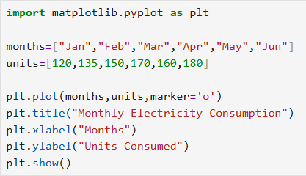

Output:
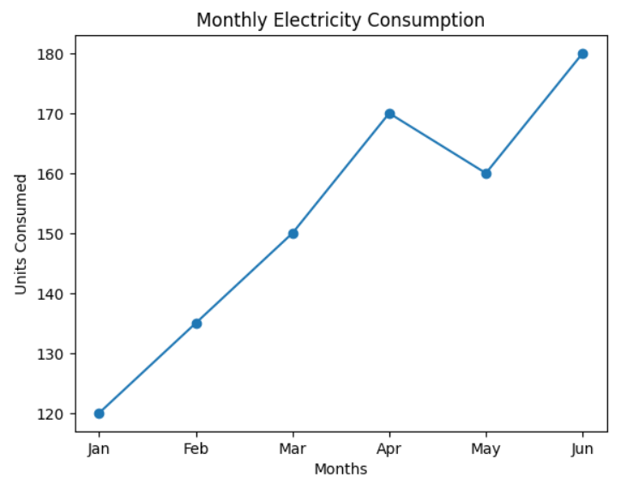

Explanation
The plot() function creates the graph.
xlabel() and ylabel() define axis names.
title() adds heading.
show() displays the visualization.
2. Bar Chart
Description
A bar chart is used to compare values between different categories using rectangular bars.
Practical Use
It is useful in comparing product sales or student marks in different subjects.
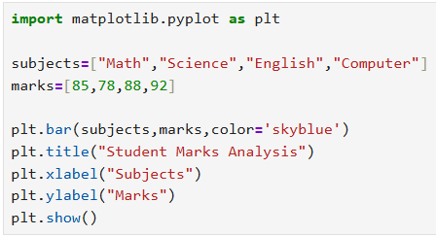
Code Example: Student Marks Comparison

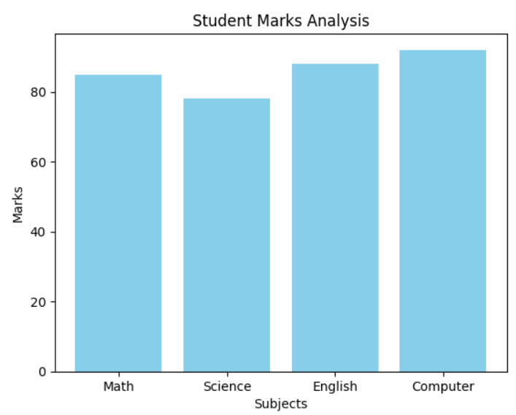
Output:

Explanation
bar() function creates the bar graph.
Each bar represents a category value.

3. Histogram
Description
A histogram shows how data is distributed by grouping values into ranges.
Practical Use
Used in analyzing age distribution or exam score distribution.

Code Example: Age Distribution in a Company
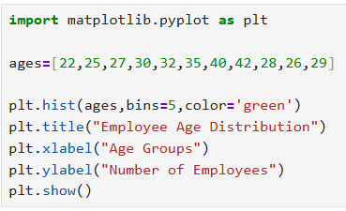

Output:
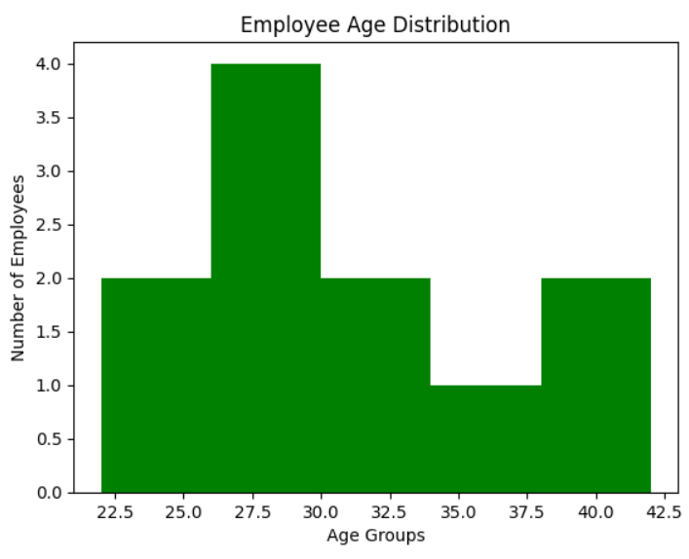

Explanation
hist() groups the data into bins.
bins decide number of groups.
4. Scatter Plot
Description
Scatter plots are used to show relationships between two variables using points.
Practical Use
Used in correlation analysis like study hours vs marks
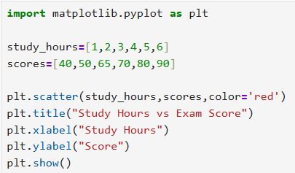
Code Example: Study Hours vs Exam Score

Output:
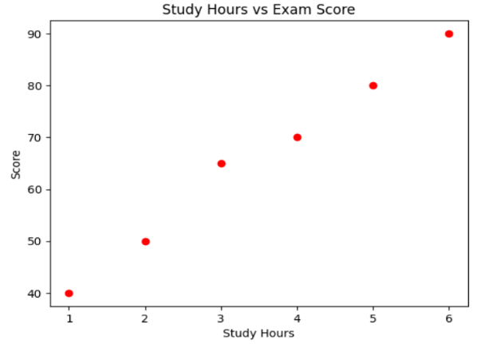

Explanation
scatter() creates the plot using points instead of lines
5. Pie Chart
Description
Pie charts represent data as parts of a whole using percentage divisions.
Practical Use
Used in showing budget distribution or time management.
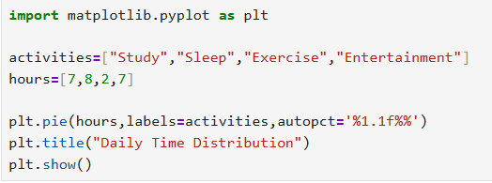
Code Example: Daily Time Management

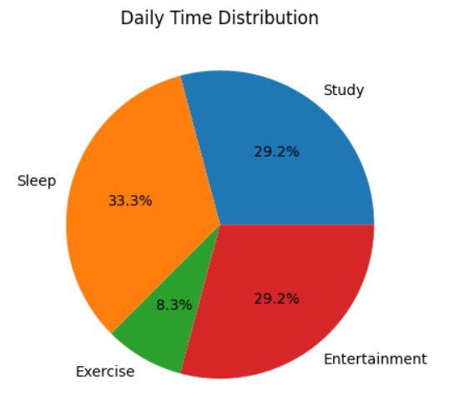
Output:

Explanation
pie() creates circular chart.
autopct shows percentage values.
SEABORN LIBRARY
Seaborn is a Python library used for creating attractive and informative statistical visualizations. It is built on top of Matplotlib, which means it uses Matplotlib internally but provides a simpler and more advanced interface. Seaborn is widely used in data science because it offers built-in themes, color palettes, and functions that make complex graphs easier to create.
Key Features of Seaborn
- Provides visually appealing default graph styles
- Supports statistical visualization
- Works directly with Pandas DataFrames
- Easy to create complex graphs with minimal code
- Includes built-in datasets for experimentation
Types of Graphs Using Seaborn
Below are some commonly used graphs created with Seaborn using real-world examples
1. Scatter Plot
Description
A scatter plot displays the relationship between two variables using individual points.
Real-World Use
Businesses can use this graph to analyze how advertising spending affects product sales.
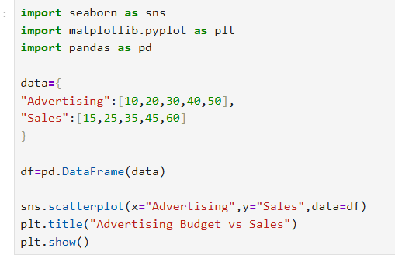
Code Example: Advertising Budget vs Sales

Output:
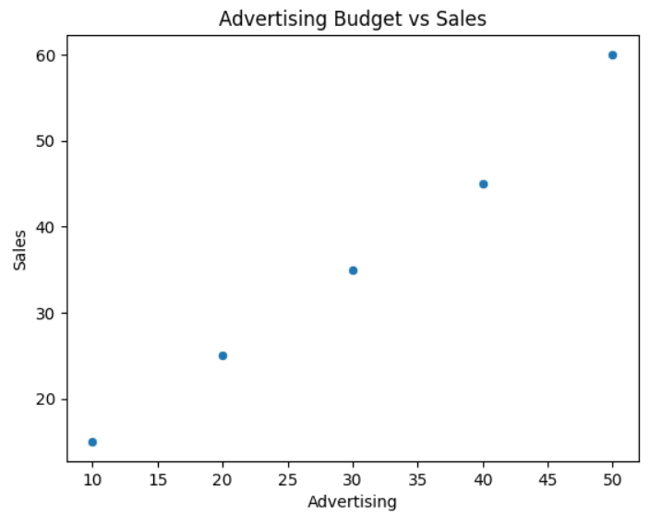

Explanation
The scatterplot() function is used to create the graph. Each point represents the relationship between advertising spending and sales.
2. Line Plot
Description
Line plots are used to show how data changes over time.
Real-World Use
Website administrators use this to monitor visitor traffic.
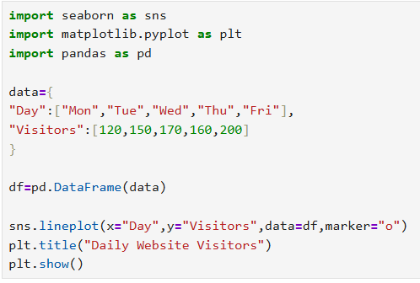
Code Example: Daily Website Visitors

Output:

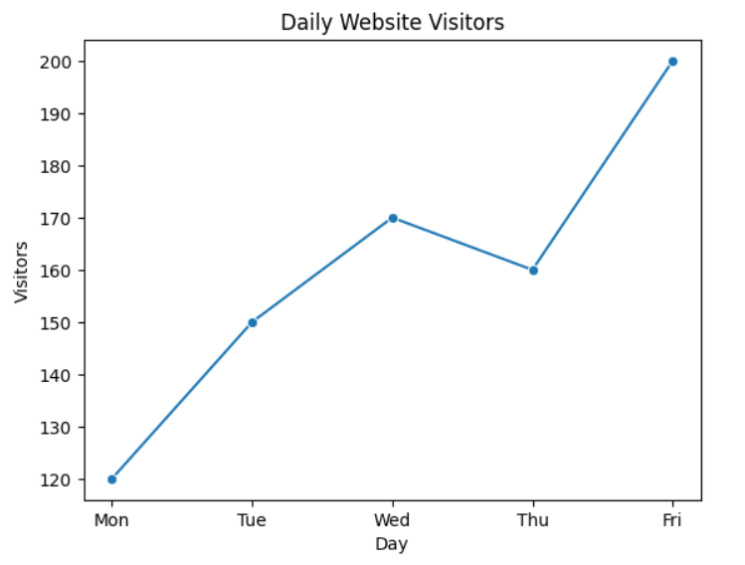

Explanation
lineplot() connects data points to show trends across different days.
3. Bar Plot
Description
Bar plots are used to compare values across categories.
Real-World Use
Companies use bar charts to compare sales of different products.
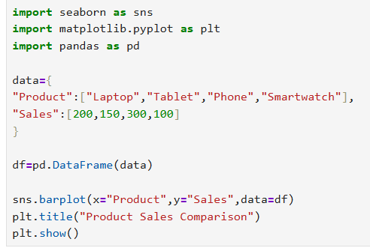
Code Example: Product Sales Comparison

Output:

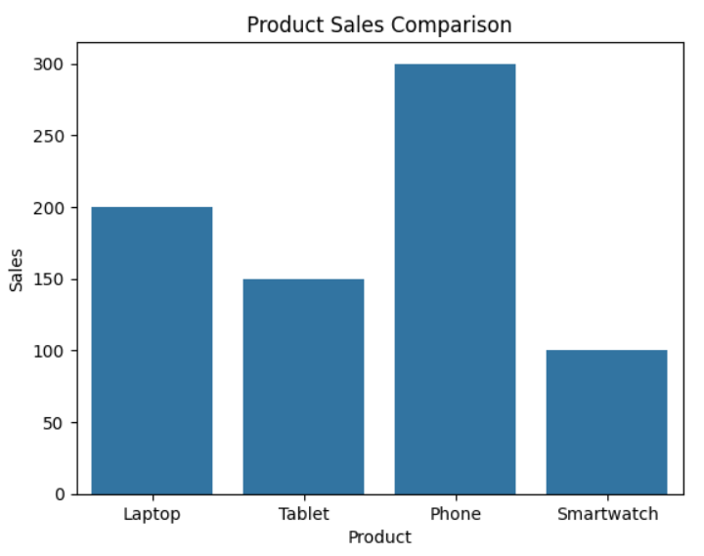

Explanation
barplot() calculates and displays the average value of each category.
4. Box Plot
Description
Box plots display the distribution of numerical data through quartiles and help identify outliers.
Real-World Use
Used in HR analytics to analyze salary ranges.
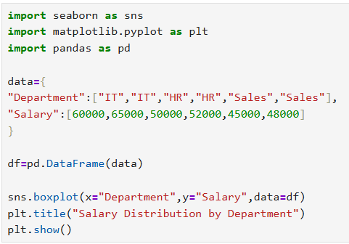
Code Example: Employee Salary Distribution

Output:

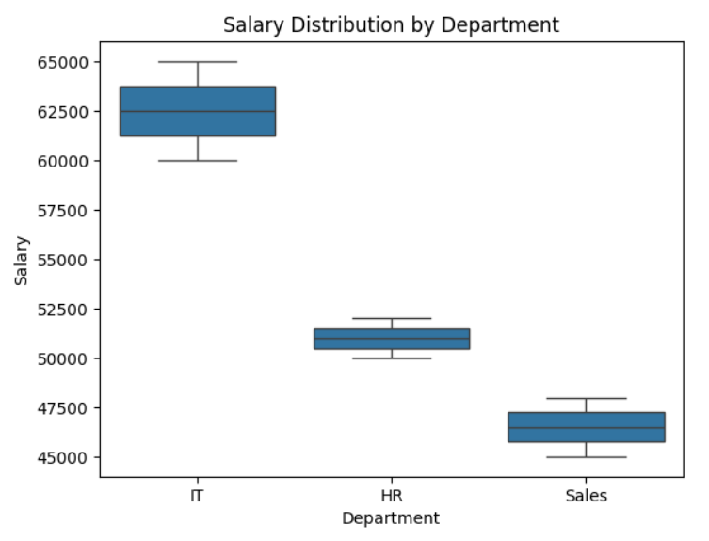

Explanation
boxplot() displays the median, quartiles, and possible outliers in the dataset.
5. Heatmap
Description
A heatmap represents data using color variations, often used to show correlations.
Real-World Use
Schools can analyze student performance across subjects.
Code Example: Student Subject Performance
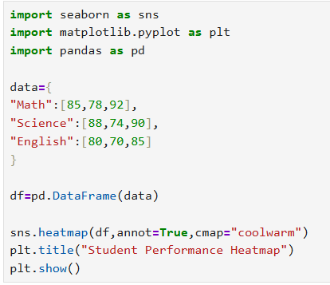

Output:

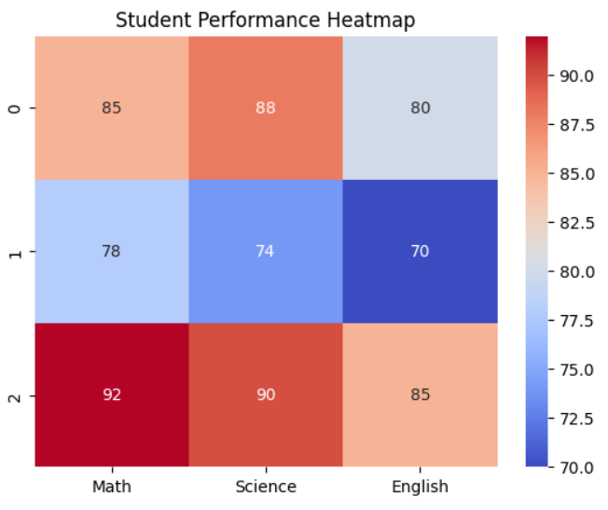

Explanation
heatmap() visualizes values using colors where higher values appear brighter.

COMPARISON OF MATPLOTLIB AND SEABORN
Data visualization libraries help in presenting data effectively. Matplotlib and Seaborn are two widely used Python libraries for this purpose. Although Seaborn is built on Matplotlib, both have different strengths and use cases.
Matplotlib
Matplotlib is a flexible visualization library that allows users to create a wide variety of graphs with detailed customization. It is suitable when full control over the graph design is required.
Advantages of Matplotlib
- Provides complete control over plot customization
- Supports many types of visualizations
- Works well with NumPy and Pandas
- Suitable for complex and detailed plots
- Large community support
Limitations of Matplotlib
- Requires more lines of code
- Default graphs are less visually attractive
- Slightly harder for beginners

Seaborn
Seaborn is a high-level visualization library that simplifies the creation of statistical graphs. It provides better design and styling compared to Matplotlib with less coding effort.
Advantages of Seaborn
- Simple and easy syntax
- Attractive default themes
- Good for statistical analysis
- Direct support for Pandas DataFrames
- Quick visualization of relationships in data
Limitations of Seaborn
- Less customization compared to Matplotlib
- Depends on Matplotlib internally
- Not ideal for very complex custom plots

Conclusion of Comparison
Matplotlib is best when detailed customization and control over plots are required. Seaborn is more suitable for quick statistical visualization and attractive graphical representation. In practical data science projects, both libraries are often used together to take advantage of their strengths.

Learning Outcome
Through this documentation, I learned how to create different types of visualizations using Matplotlib and Seaborn. I also understood how different graphs help in analyzing real-world datasets and how to choose the right visualization library based on project requirements.

